December 9, 2015

Revision 2.0

Installation Guide: NIST HL7v2 Validation Tools

Submitted by:

National Institute of Standards and Technology (NIST)

Table of Contents

Introduction 3

War File Installation Quick Guide 4

War File Installation Detailed Guide – Windows 7 5

I. Download and Install Java 5

II. Download and Install Tomcat 7 10

III. Run Tomcat 16

IV. Copy war file into Tomcat Webapps folder 19

# Introduction

This Installation Guide provides step-by-step instructions to install the war files of the following NIST HL7v2 Validation Tools. The war files may be downloaded from the Documentation Page of the tools online:

* Electronic Laboratory Reporting (ELR) 2014 and 2015 Edition - <http://hl7v2-elr-testing.nist.gov>
* Syndromic Surveillance 2014 Edition - <http://hl7v2-ss-testing.nist.gov>
* Immunization Messaging 2014 Edition- <http://hl7v2-iz-testing.nist.gov>
* Lab Results Interface (LRI) 2014 Edition - <http://hl7v2-lab-testing.nist.gov>
* Immunization Messaging 2015 Edition – <http://hl7v2-iz-r1.5-testing.nist.gov>
* Syndromic Surveillance 2015 - <<http://hl7v2-ss-testing.nist.gov>>

# War File Installation Quick Guide

1. Download and Install Java version 5 or later.
2. Download and Install Tomcat 7.
3. Open the Tomcat bin folder. (For example - C:\Program Files\Apache Software Foundation\Tomcat 7.0\bin)
4. Right click on the Tomcat7w file and select "Run as administrator". (Note: If you don’t have administrator privileges, contact your administrator.)
5. In the Tomcat 7 Properties window, select Startup Type "Automatic". Apply the settings.
6. Start the Tomcat service if it is not already started.
7. Check the status of the Tomcat service by opening up a browser window and navigating to: <http://localhost:8080/>. The Tomcat page should load successfully.
8. Copy and paste the Validation Tool war file into the Tomcat webapps folder. (For example - C:\Program Files\Apache Software Foundation\Tomcat 7.0\webapps)
9. Copy the name of war file and paste it after the URL address in the browser window: “<http://localhost:8080/>”. (For example, for the Immunization war file “mu-immunization-1.0.14-SNAPSHOT.war”, the URL becomes “http://localhost:8080/mu-immunization-1.0.14-SNAPSHOT”.)
10. Press Enter or refresh the browser page. The Validation Tool is now loaded and available for use locally on your computer.

# War File Installation Detailed Guide – Windows 7

In order to run the Validation Tool war file, Java (version 5 or later) and Tomcat 7 must be installed. Tomcat must also be running. If both Java and Tomcat (with the correct versions) have been installed, skip to Section III. Run Tomcat. Otherwise, begin by following the steps below to install Java and Tomcat.

### Download and Install Java

1. First, check if Java is already installed:
   1. Click on the Start/Windows Icon and type “cmd” in the search box to open up the Command prompt.
   2. Type “java –version” in the command prompt.
      1. If the Java version is listed and version is 5 or later (as shown below), skip to Section II. Download and Install Tomcat 7.

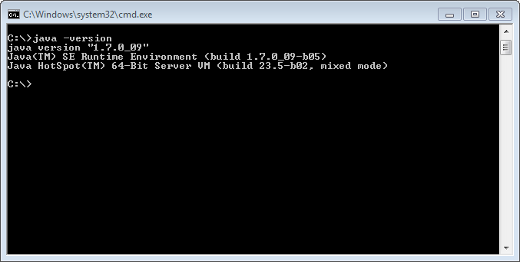

* + 1. If you receive an “Unknown Command” error message or if the Java version listed is 5 or earlier, continue with the remaining steps to download and install Java.

1. Navigate to <http://www.oracle.com/technetwork/java/javase/downloads/index.html>
2. Click on the Download button for Java Platform (JDK).

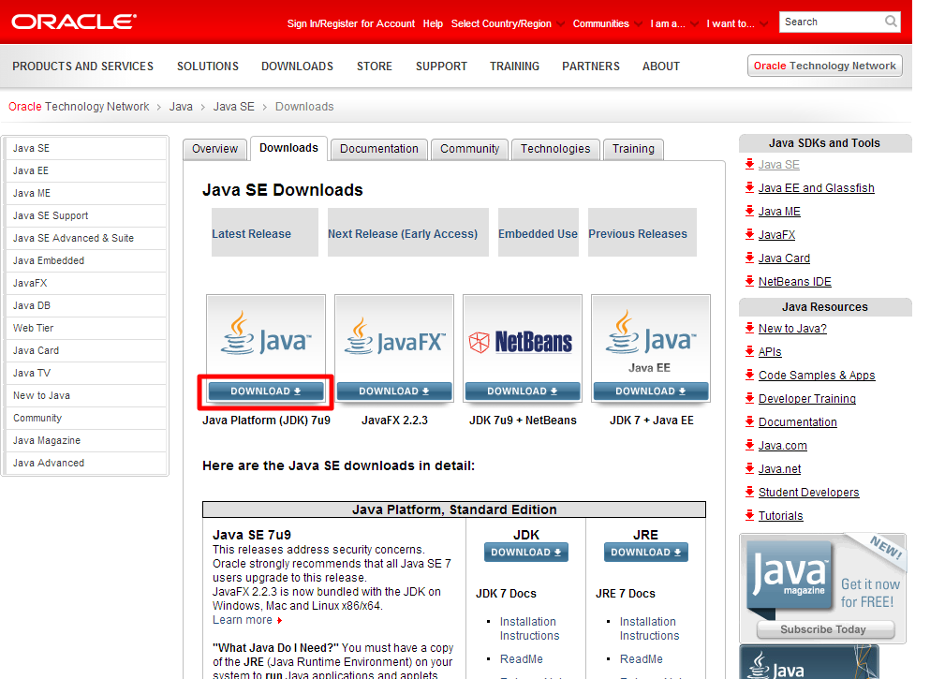

1. Check the button next to the Accept License Agreement option for the latest version of Java.

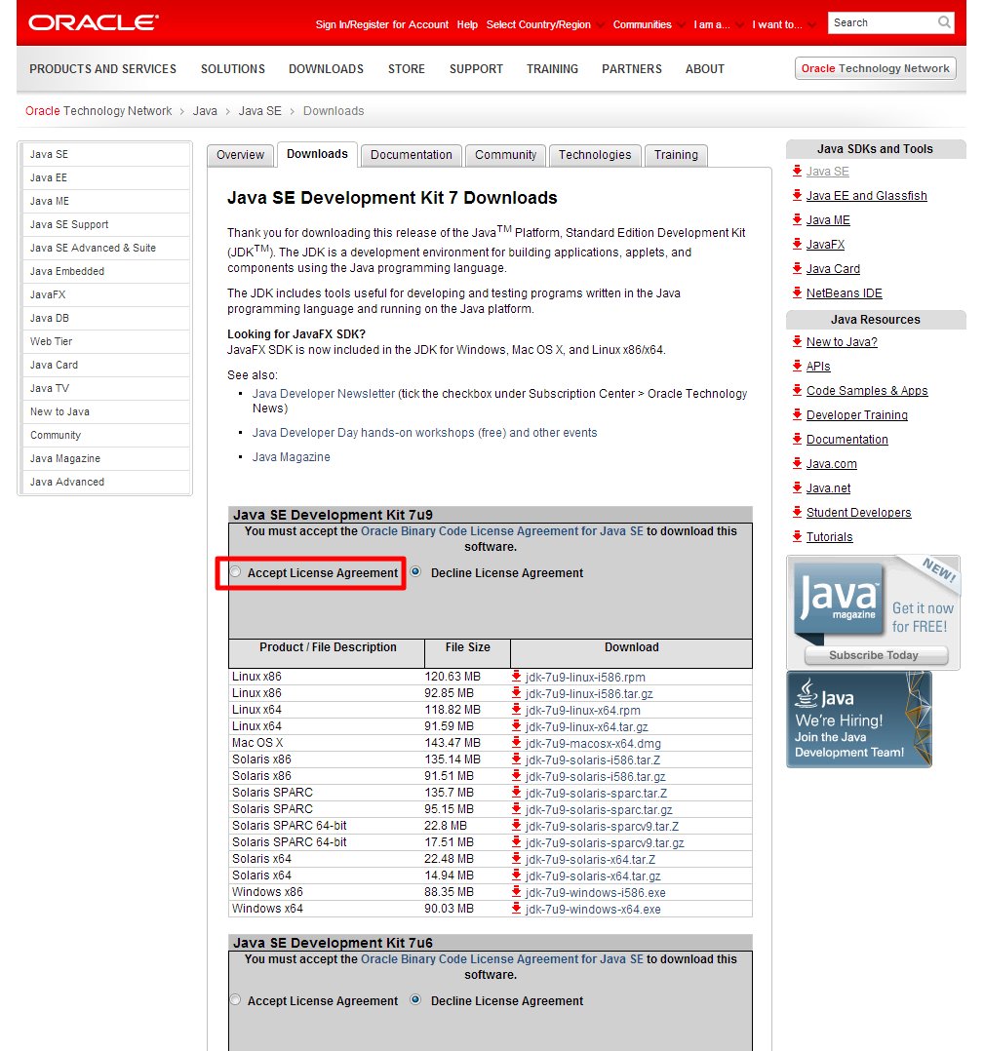

1. For 64-bit machines, find “Windows x64” in the Product/File Description column and click on the corresponding download link. For 32-bit machines, click on the download link for “Windows x86”.

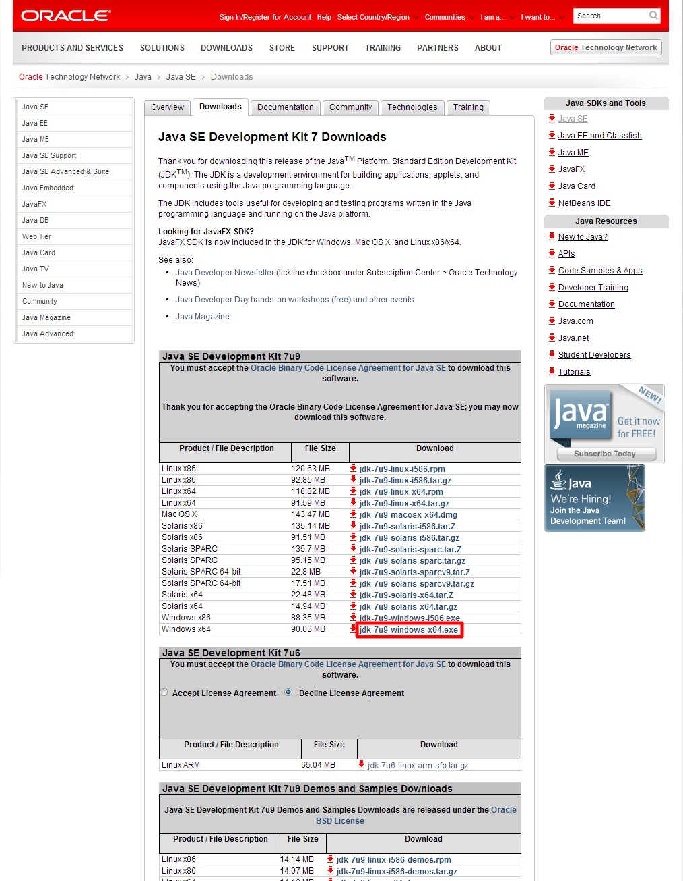

1. Save the installation file.
2. Open the folder containing the installation file and double click on the executable file to begin the installation.
3. The Java Installation Wizard window opens. Click on the Next button.

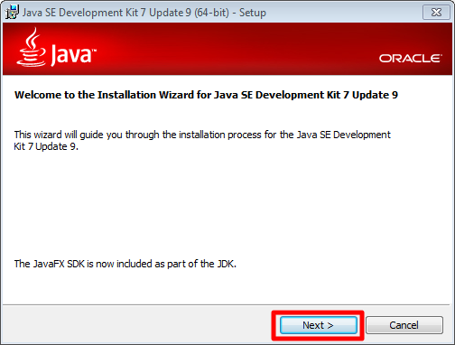

1. Select optional features to install, if desired, or leave unselected. Click on the Next button.

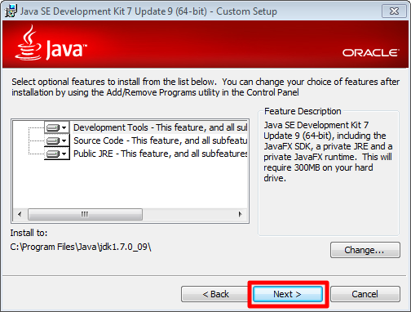

1. Select the folder to save the installation files by clicking on the Change button or use the default folder displayed. Click on the Next button.

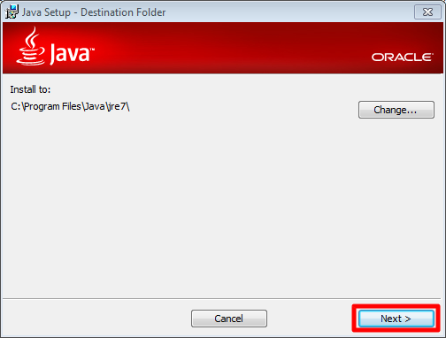

1. Click on the Close button to close the Installation Wizard window. Java is now installed. If prompted, reboot the computer.

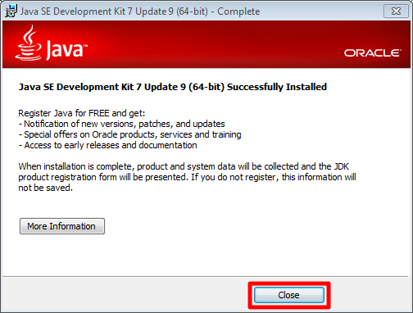

### Download and Install Tomcat 7

1. First, check if Tomcat is already installed:
   1. Click on the Start/Windows Icon and select All Programs.
      1. If Apache Tomcat is listed, skip to Section III. Run Tomcat.

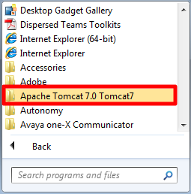

* + 1. If Apache Tomcat is not listed, continue with the remaining steps to download and install Tomcat.

1. Navigate to <http://tomcat.apache.org/download-70.cgi>
2. Change the mirror, if desired, by clicking on the drop down button. (For instance, <http://www.bizdirusa.com/mirrors/apache/>) Otherwise, leave the mirror as selected.

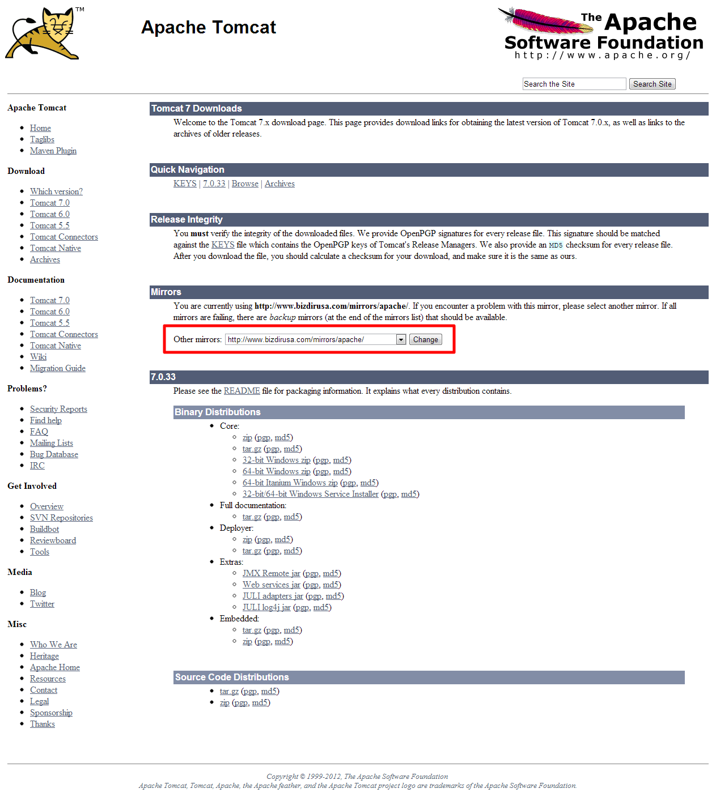

1. Scroll down to the Binary Distributions heading. Under the Core section, click on the “32-bit/64-bit Windows Service Installer” link.

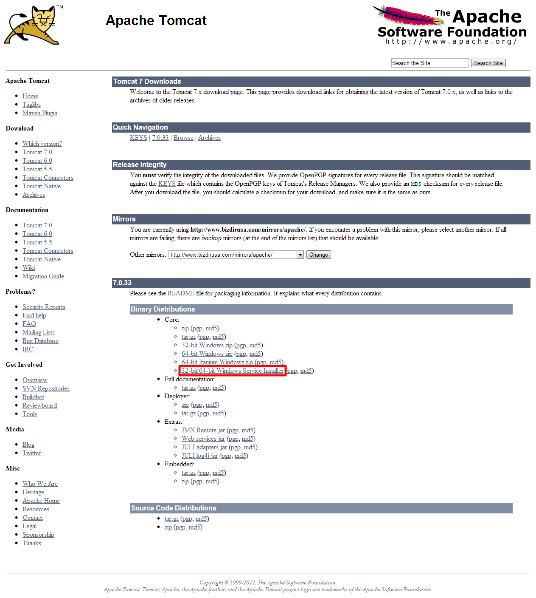

1. Save the installation file.
2. Open the folder containing the installation file and double click on the executable file to begin the installation.
3. The Setup Wizard window opens. Click Next.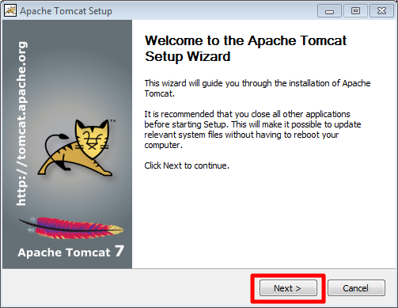
4. Scroll through the license agreement and click on the I Agree button.

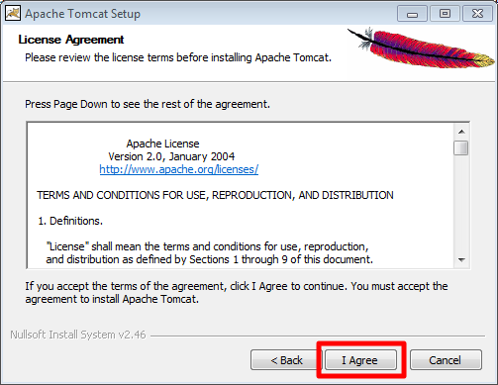

1. Check the boxes next to the features you’d like to install. Click on the Next button.

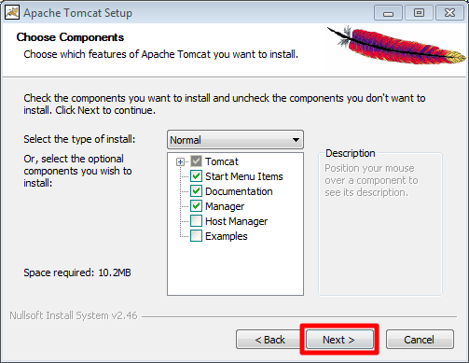

1. The port information is automatically populated. Click on the Next button.

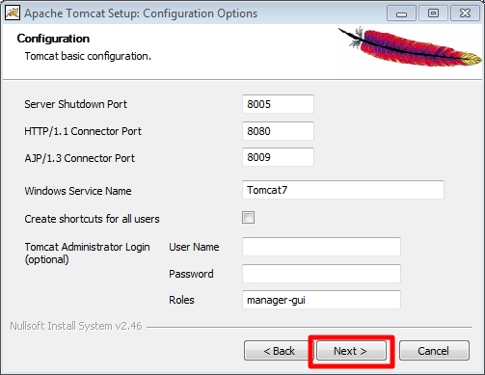

1. The Java Virtual Machine path is automatically populated. Click on the Next button.

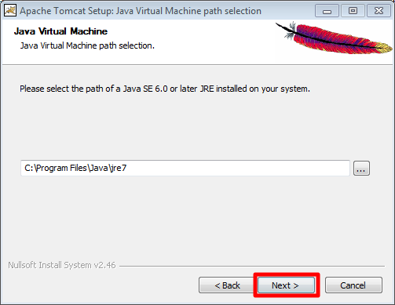

1. Select the folder to save the installation files by clicking on the Browse button or use the default folder displayed. Click on the Install button.

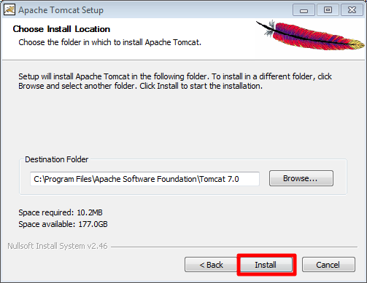

1. Click on the Finish button to close the Setup Wizard. Tomcat is now installed and will begin running.

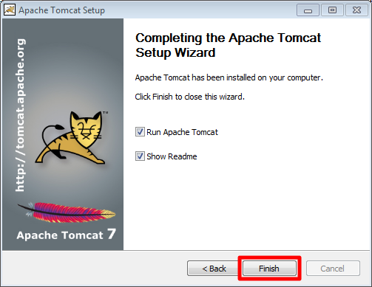

### Run Tomcat

1. Using Windows Explorer, open the folder - C:\Program Files\Apache Software Foundation\Tomcat 7.0\bin (or whichever folder Tomcat was installed in).
2. Right click on the Tomcat7w file.
3. Select "Run as administrator". (Note: If you don’t have administrator privileges, contact your administrator.)

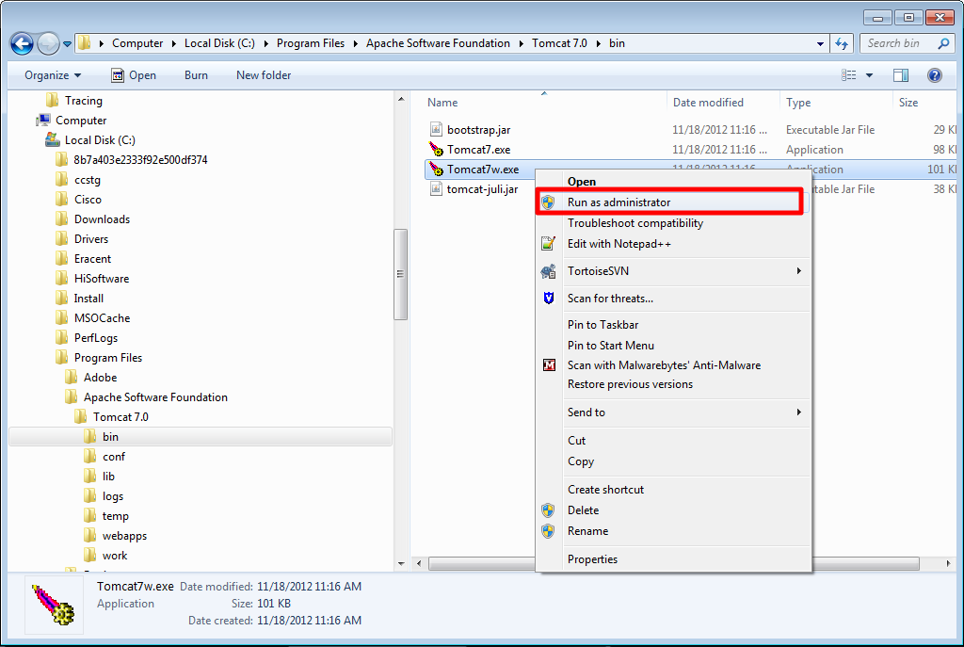

1. In the Tomcat 7 Properties window, select Startup Type "Automatic". (Note: This setting will automatically start the Tomcat service at windows startup. You may choose to leave Startup Type to “Manual”, but you will have to start and stop Tomcat manually.)

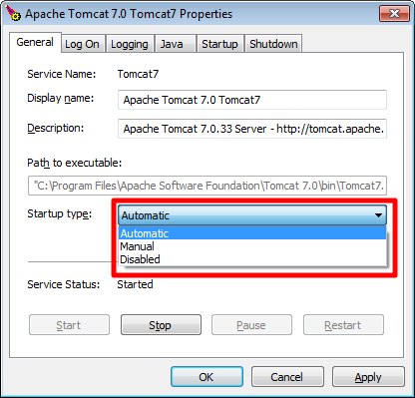

1. Click on the “Apply” button, then the "OK" button.

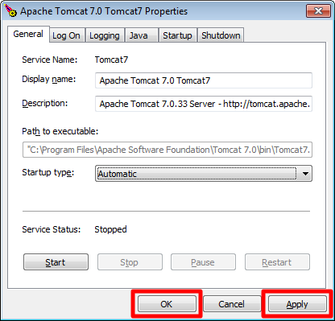

1. Start the service if it is not already started by clicking on the “Start” button.

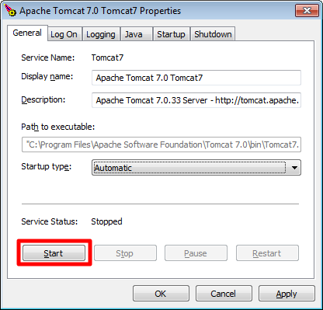

1. If you need to run several validation tools, it is strongly recommended that you allocate more memory to Tomcat. This can be done by navigating to the Java tab, and entering the suggested values of 256 in Initial memory pool and 512 in Maximum memory pool. Click on the Apply button to save the values.

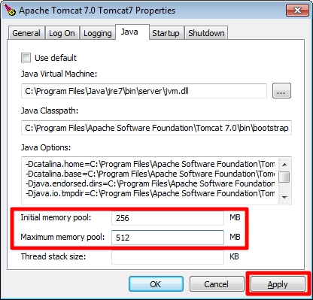

1. Check the status of the service by opening up a browser window and navigating to: <http://localhost:8080/>. The Tomcat page should load successfully.

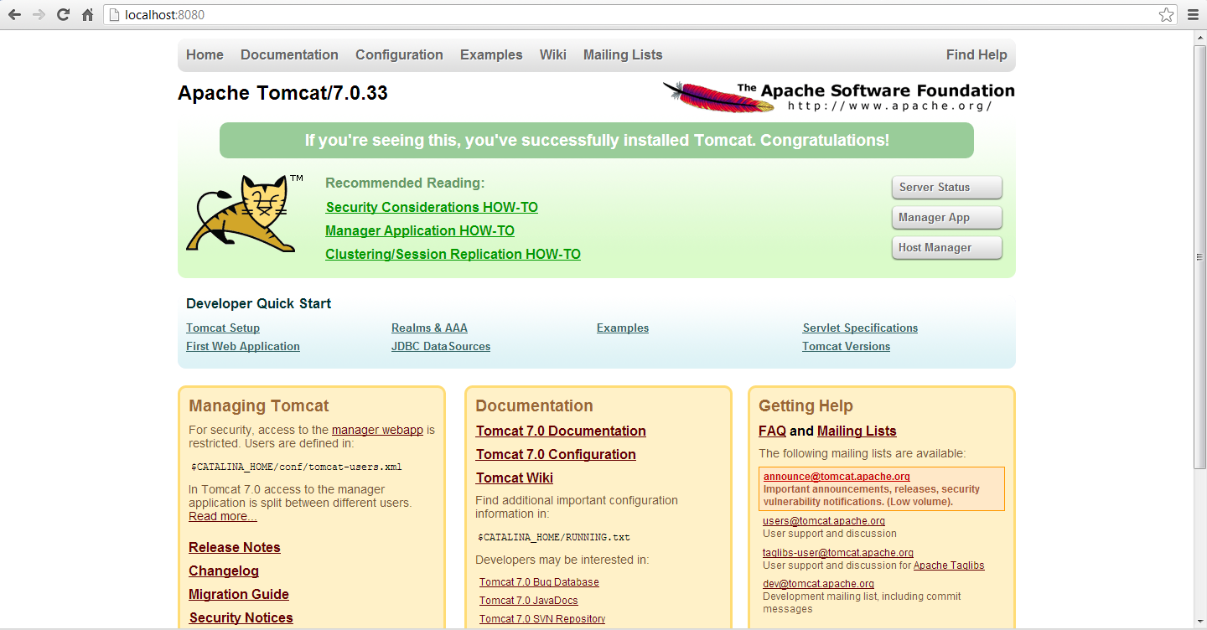

### Copy war file into Tomcat Webapps folder

1. Download the Validation Tool war file by clicking on the Documentation tab of the Validation Tool and expanding the “Validation Tool Download” heading by clicking on it.

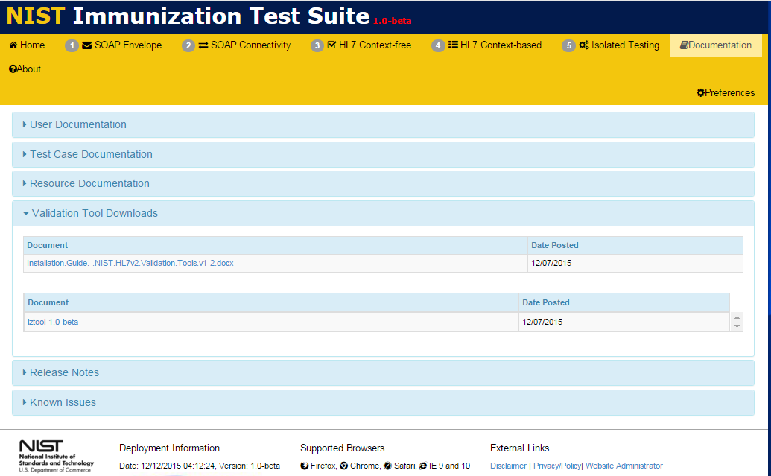

1. Click on the war file link to download the war file.

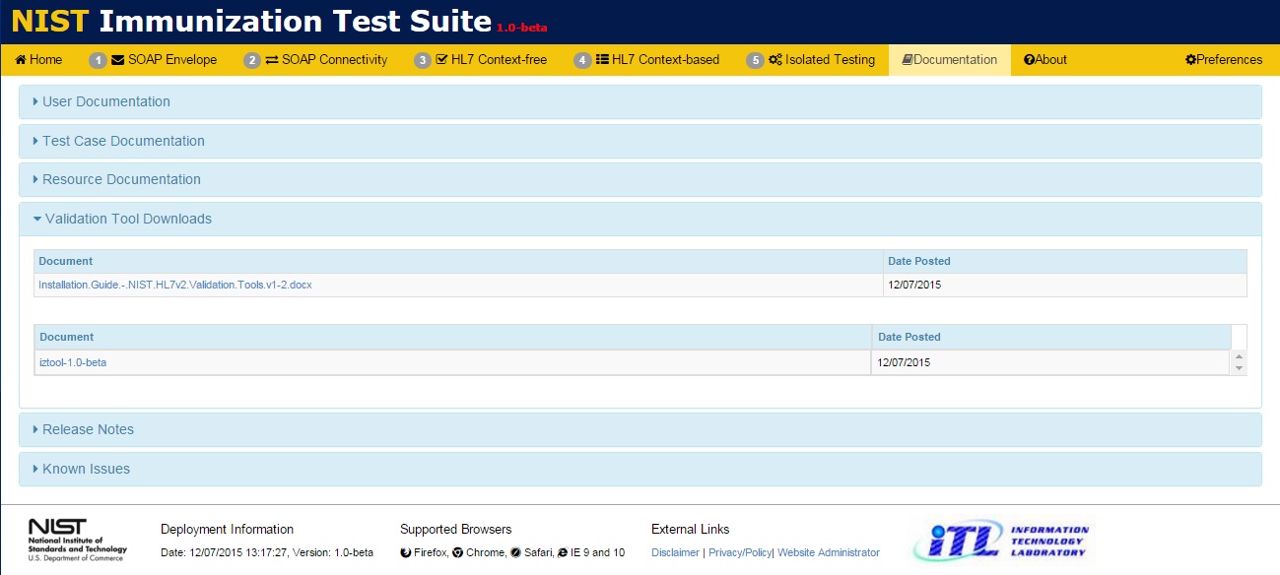

1. Open the folder containing the downloaded war file and copy the file onto the clipboard.
2. Open the webapps directory folder: C:\Program Files\Apache Software Foundation\Tomcat 7.0\webapps.
3. Paste the war file into the webapps folder.
4. Copy the name of war file and paste it after the URL address in the browser window: “<http://localhost:8080/>”.

For example, for the Immunization war file “mu-immunization-1.0.14-SNAPSHOT.war”, the URL becomes “http://localhost:8080/mu-immunization-1.0.14-SNAPSHOT”.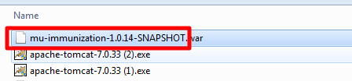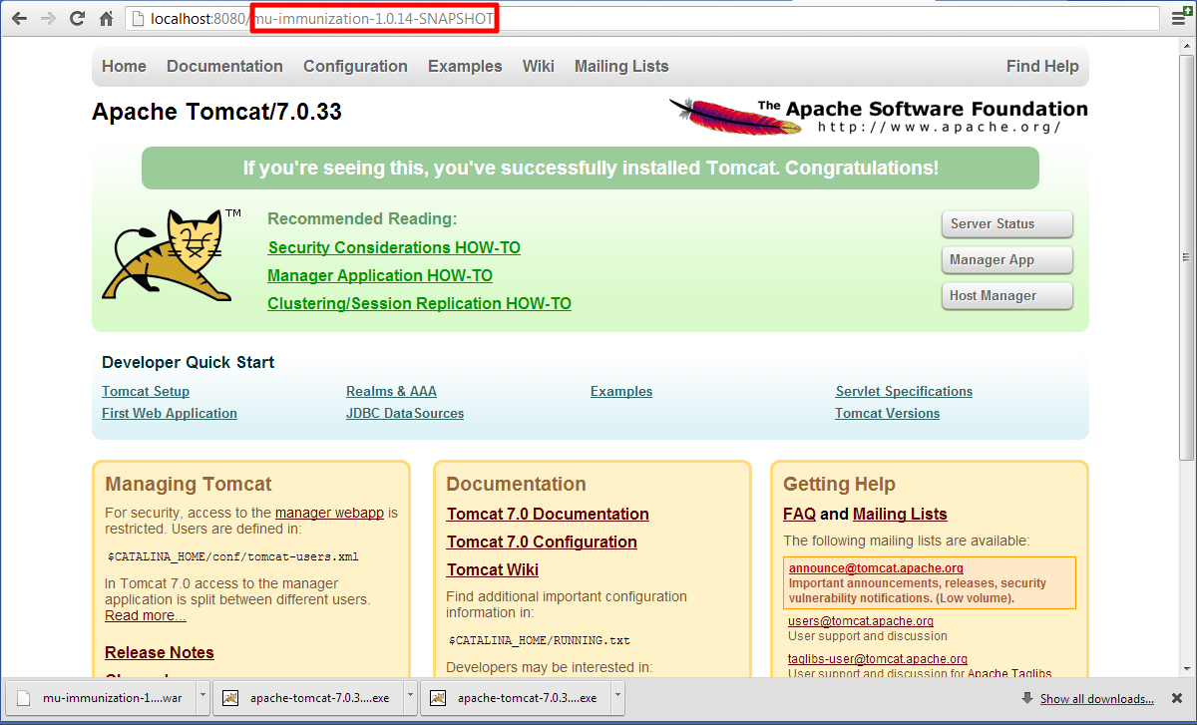

1. Press Enter or refresh the browser page. The Validation Tool is now loaded and available for use locally on your computer.

